c

**INTERNATIONAL SCHOOL**

**COURSE PROJECT 1**

**CMU-CS 246**

**DEFINDED PROCESS DOCUMENT**

Version: 1.1

**SIMPLE CALCULATOR SYSTEM - SC**

**Mentor: Nguyen Dang Quang Huy**

***Team Member*:**

Thanh, Tran Nguyen Duy

Thien, Nguyen Ngoc

Khang, Tran Quoc

Dinh, Dang Quoc

Huy,Van Viet Bao

**Approved by Huy Nguyen Dang Quang,Msc**

**Project Plan Review Panel Representative:**

Name Signature Date

**Course Project 1- Mentor:**

Name Signature Date

Da Nang, 01/2024

**PROJECT INFORMATION**

|  |  |
| --- | --- |
| **Project Acronym** | SC |
| **Project Title** | Simple Calculator System | | | |
| **1Start Date** | 25 – Jan – 2024 | **End Date** | 18– Feb –2024 | |
| **Lead Institution** | International School, Duy Tan University | | | |
| **Team Member** | **Name** | **Email** | | **Phone** |
| 28219448044 | Thien Nguyen Ngoc | anh.ty.dn111@gmail.com | | 0707155003 |
| 28214634771 | Thanh Tran Nguyen Duy | doyouwanttobe23@gmail.com | | 0395114654 |
| 28211102614 | Dinh Dang Quoc | dinhfury2004@gmail.com | | 0867530103 |
| 28211100259 | Khang Tran Quoc | khangtran12pro@gmail.com | | 0338917278 |
| 28210200735 | Huy Van Viet Bao | hdegamer4@gmail.com | | 0339707246 |

**PROJECT PLAN DOCUMENT**

|  |  |  |  |
| --- | --- | --- | --- |
| **Document Title** | DEFINDED PROCESS DOCUMENT | | |
| **Author(s)** | Team 4 | | |
| **Date** | Jan 25th, 2024 | **File name:** | DefindedProcess_SC_Team_4_v1.1.docx |
| **URL** | https://drive.google.com/drive/folders/1XsjP3887YuNl4E8YRmeDQmnNr0JNnVw_?fbclid=IwAR1npPU37wub7awmm4oLGPfSYMRZIwNWM7KVq6PoMy8BXA4z39mlktqWrrY | | |
| **Access** | Huy Nguyen Dang Quang and Team 4 | | |

**SIGNATURE**

**Document Approvals:** The following signatures are required for approval of this document.

|  |  |  |  |
| --- | --- | --- | --- |
| **Mentor** | Huy, Nguyen Dang Quang | **Signature:** |  |
| **Date:** |  |
| **Scrum master** | Thanh, Tran Nguyen Duy | **Signature:** |  |
| **Date:** |  |
| **Product Owner** | Thien, Nguyen Ngoc | **Signature:** |  |
| **Date:** |  |
| **Team member(s)** | Huy, Van Viet Bao | **Signature:** |  |
| **Date:** |  |
| Khang, Tran Quoc | **Signature:** |  |
| **Date:** |  |
| Dinh, Dang Quoc | **Signature:** |  |
| **Date:** |  |

**REVISION HISTORY**

|  |  |  |  |
| --- | --- | --- | --- |
| **Version** | **Person(s)** | **Date** | **Description** |
| **1.0** | Thien, Nguyen Ngoc | Jan 29th, 2024 | Draft |
| **1.1** | Thien, Nguyen Ngoc | Jan 26th, 2024 | Update |

**TABLE OF CONTENTS**

**1. PROJECT DESCRIPTION 4**

**2. PROJECT DEVELOPMENT APPROACH 5**

**2.1. TECHNICAL PROCESS 5**

**2.1.1. REASON FOR SELECTING 5**

**2..1.2 WATER FALL METHODOLOG 5**

**2.1.3. WATER FALL PROCESS 6**

**3. REFERENCES 7**

# 1. PROJECT DESCRIPTION

|  |  |  |  |
| --- | --- | --- | --- |
| **Project code** | CS | **Contract type** | Internal Project |
| **Customer** | N/A | **End-user** | Management,  employee |
| **Project type** | Internal | **Project Manager/**  **Scrum Master** | Thanh,Tran Nguyen Duy |
| **Project category** | Perform Calculations | **Business Domain** | AI |
| **Application type** | Form |  |  |

# 2. PROJECT DEVELOPMENT APPROACH

## 2.1. TECHNICAL PROCESS

## We use the Water Fall method in our project, besides using software tools to manage work, assign tasks to team members such as Trello, Slack, Google Drive, Discord. And for project requirements, we use Netbeans (java language programing)for application development.

## 2.1.1. REASON FOR SELECTING

## The Waterfall model is a software development model suitable for small-scale software projects with clear requirements and not many changes during the development process. The Calculator application is a simple application, has clear requirements and does not have many changes during development, so the Waterfall model is a suitable choice to develop this application.

## Having team members complete small, measurable amounts of work helps keep them focused and motivated. While our team is a small team with little experience in project development. Therefore, we cannot avoid problems that arise in the software development stages, and requirements can be changed to be more suitable. The traditional model that requires managerial skills and high accuracy, will not suit our team. Applying the Water Fall model will help us to solve these problems, bring a lot of experience and best performance for project development.

## 2..1.2 WATER FALL METHODOLOG

* The Agile methodology was firstly developed for the software industry.
* The task was to optimize and improve the development process and to try to identify and quickly correct problems and defects.
* This methodology allows providing better output, more quickly, through short and interactive sessions/sprints.
* In the era of digital transformation, where many organizations are migrating to a digital workplace, the Agile methodology suits perfectly companies that are looking to transform the way in which projects are managed and the way they operate as a whole.

2.1.3. WATER FALL PROCESS

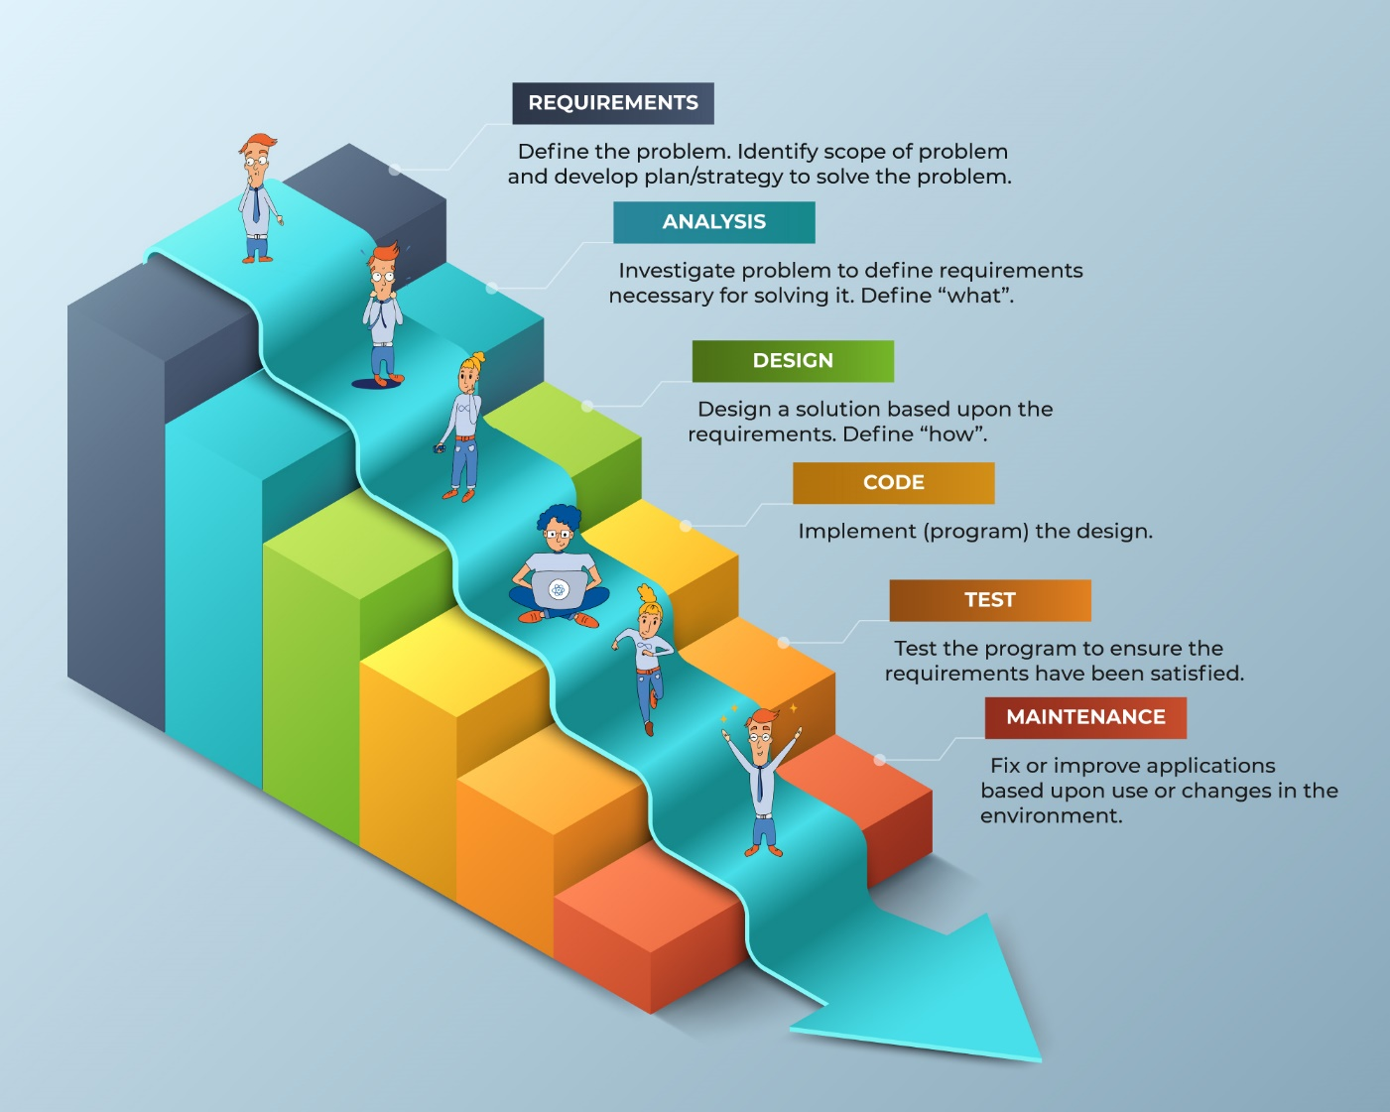

**Figure1:** Scrum master

* Project phases are clearly defined.
* Project management and control is easier.
* Allows relatively accurate estimates of project costs and time
* Work done will better meet the customer’s needs.
* Requirements are clearly defined from the beginning and not much changes during development.

**3. REFERENCES**

1. <https://en.wikipedia.org/wiki/Waterfall_model>
2. <https://www.javatpoint.com/software-engineering-waterfall-model>
3. <https://www.tutorialspoint.com/adaptive_software_development/sdlc_waterfall_model.htm>
4. <https://www.pmi.org/learning/library/agile-versus-waterfall-approach-erp-project-6300>